Final Group Project - Database Design and Implementation
Group Name: Group 1
Instructions
This project aims to apply the skills and knowledge acquired in SQL databases to establish a comprehensive database for a business, industrial, academic, or entertainment system. For example, you might choose to create a database that simulates a real university system, a supply chain management system, a sports management system, or any other system that you find interesting and requires robust database management.
Your database should be sufficiently large and complex to demonstrate your proficiency in using data definition statements (DDL), data manipulation statements (DML), and data retrieval statements (DQL). Specifically, the database should include at least 10 tables representing different entities within your chosen system.
In addition to creating and managing the database, you are also required to prepare datasets from your database that can be used for machine learning projects. This means your database should be designed in a way that allows easy extraction of relevant data for analysis and predictive modeling.
Breakdown
The key components of this project include:
- Database Design: Develop a schema that includes at least 10 interrelated tables. Ensure that the schema adheres to DB principles to eliminate redundancy and ensure data integrity. Design the ER diagram representing the developed DB.
- Data Definition Statements (DDL): Use DDL statements to create tables, define relationships (such as primary and foreign keys), and enforce constraints (such as unique, not null, and check constraints).
- Data Manipulation Statements (DML): Populate your tables with realistic data using DML statements. This should include inserting, updating, and deleting records to reflect dynamic data management.
- Data Retrieval Statements (DQL): Craft SQL queries to retrieve datasets from the developed database for the purpose of conducting machine learning projects. This should include queries for selecting specific records, joining multiple tables, grouping data, and performing aggregate calculations.
Don't limit yourself to the knowledge provided in this course. You are encouraged to apply new database concepts that were not covered in our course. This initiative will be highly valued and positively influence your final grade. By the end of this project, you should have a fully functional database that not only demonstrates your SQL capabilities but also provides a valuable resource for further machine learning and data analysis projects.
Project Deliverables
The following items should be submitted during the hybrid class in Week 11:
- SQL files containing all the coding work accomplished in this project.
- A link to the ER diagram created in draw.io.
- A PDF copy of the final report.
- A PowerPoint presentation.
Due on Mar 23, 2025 11:59 PM
Available on Mar 1, 2025 10:00 PM. Access restricted before availability starts.
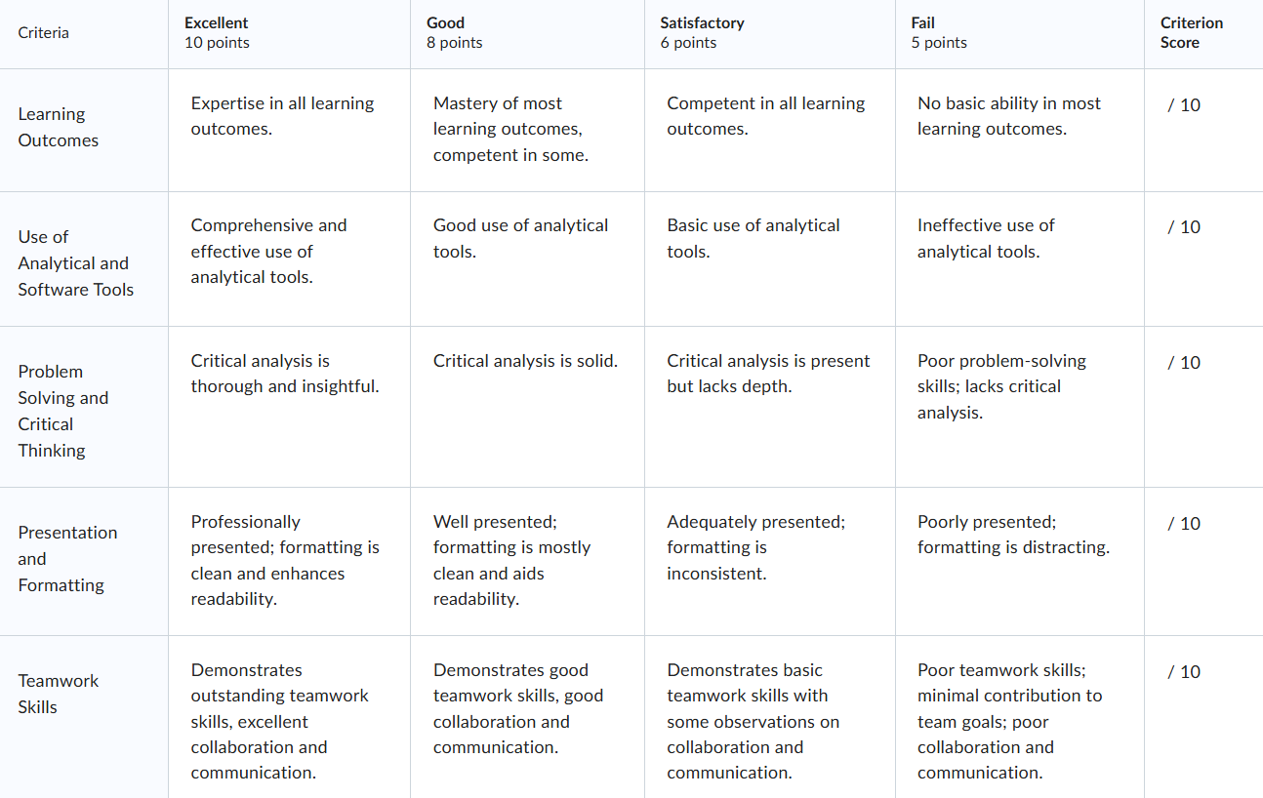
Available until Mar 23, 2025 11:59 PM. Access restricted after availability ends.

